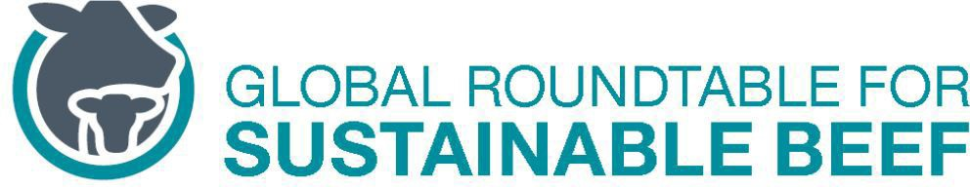

National Roundtables Minutes

**August 18, 2022**

GRSB Members Present: Max Makuvise (SARRSB), Diana Caterine Forero (MGSDM), Megan Skiffington, (NZ), Jacob Betros (ABSF), Luiza Bruscato (GTPS), German Serrano (MGSC), Hugo Sanchez (MPCS), Edward Moreno (MBCS), Roz Davis (ERBS), Sam Werth (USRSB), Anne Gillespie (Leather)

GRSB Staff Present: Ruaraidh Petre, Josefina Eisele, Kellie Lasack

Roundtable Presentation

No presentation was given.

Consumer Survey

Petre advised the consumer survey from Howard Parry Husbands will be sent to all GRSB members today requesting consumer research information available to share, and encouraged member response. Petre added GRSB would not have access but only Howard Parry Husbands would be privy to their responses for the purpose of the meta-analysis, and would not be used publicly. This research will help identify global trends and consumer attitudes toward beef and beef sustainability. These results will be presented at the Global Conference.

Global Standard

Petre shared at GRSB’s inception, a Global Standard was avoided primarily due to the complexity to standardize specifications as any standard would need to be more of a broad and general scale. A couple of years ago, GRSB was approached by the British Standards Institute (BSI) regarding the idea to establish a global standard for sustainable beef. BSI then proceeded to explore standardization of Regenerative Ag which was unsuccessful. BSI then solicited support from the World Farmers Organization to sponsor the development of a global standard for sustainable beef. Petre feels the research of GRSB members is proprietary information and if any standardization would be done, GRSB should own such process. Petre suggested using GRSB’s Principles and Criteria and codify them as a meta-standard, meaning any standard at a national level would be benchmarked to that meta-standard.

GCSB 2022

Petre advised GRSB will have an introduction video at the Global Conference highlighting each of the National Roundtables’ goals work. GRSB is requesting very brief video snippets (1-3 minutes max) that will help paint a global picture of what’s currently happening in the fields. Please submit your videos to GRSB as early in September as possible. Lasack added that footage does not need to be anything fancy and can be easily provided with a cellular device. Kellie Lasack will be doing the editing. Please contact Lasack directly with any questions at [kellie.lasack@grsbeef.org](mailto:kellie.lasack@grsbeef.org). Lasack will provide an email to the roundtables a summary of helpful parameters for the videos.

Petre reiterated the importance of global representation of the National Roundtables at the conference and GRSB needs to know which National Roundtables will be present and who that representative will be. Currently, GRSB is aware that Canada, New Zealand, Australia and U.S. will be present. Luiza Bruscato (GTPS) confirmed her attendance, as did Roz Davis (ERBS). Hugo Sanchez advised that the MPCS will send 4-5 members attending. Petre also shared the challenges for many members to be able to attend due to airfare increases. As done in the past, GRSB is seeking sponsorships from organizations such as FAO, Solidaridad and the Moore Foundation. If there are any members that can help, please let GRSB know. Also, let GRSB know if you are not able to attend without having financial support.

Goals Monitoring and Reporting

Petre gave an update that GRSB has contracted SureHarvest to help with the reporting of the Global Goals. SureHarvest has a meeting scheduled with the National Roundtables on July 28th, 3:00-4:00 p.m. Central US/Canada. A recording of this meeting will be replayed on a second call with Petre and a SureHarvest representative live on the call to answer any questions for those not able to make the first call. This call will have translation, as well as Spanish and Portuguese translation of all materials produced so all responses to questionnaires may be done in English, Spanish or Portuguese. SureHarvest will present an outline of the framework and a survey questionnaire that will help GRSB members and roundtables and its’ members contribute the necessary data for the monitoring and reporting of the Global Goals. For Europe, there will be a second call scheduled to play the recording from the July 28th call and Petre, as well as a SureHarvest representative will be live on the call for any feedback or questions. The materials will be distributed as soon as they are available.

Social Mediate Updates

Lasack gave a brief update she has been working with some of the roundtables on their respective social media posts, and reiterated her availability to help all the roundtables and to please feel free to contact her directly at [kellie.lasack@grsbeef.org](mailto:kellie.lasack@grsbeef.org) with any questions or material for posting.

Future Agenda Items Requested

Please submit any request for discussion topics to [Julie.james@grsbeef.org i](mailto:Julie.james@grsbeef.org%20i)n advance of the next meeting to be added to the agenda.

AOB

Upcoming GRSB member connection and networking opportunities through travels are as follows:

* Jacob Betros (AU) will be in Dublin in early Oct at GASL, as well as the Global Conference in the U.S. and other meetings in Europe
  + Josefina is planning on attending GASL
* Sam Werth (US) will be in Dublin – Societal Role of Meat, Oct 19-20
  + Megan Farley (US) will be in Sacramento, CA the preparatory meeting
  + Lasack requested information on these meetings.

The next Roundtable Meeting will be on **Thursday, September 15, 2022, 3:00 – 4:00 pm Central US/Canada). CRSB** will be presenting.